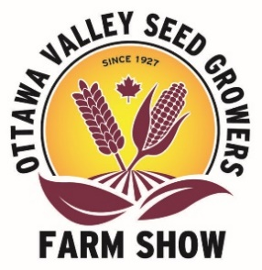

**Youth Scholarships 2025**

The Ottawa Valley Seed Growers Association is pleased to offer up to four $2,500 scholarships to recognize interest, knowledge and achievement in the Ottawa Valley and surrounding agricultural community.

The scholarships are available to youth of Eastern Ontario and Western Quebec enrolled in at least the second year of studies at any post-secondary College or University, and planning to pursue a career in agriculture. Previous winners are not eligible to receive the scholarship again.

|  |  |  |  |
| --- | --- | --- | --- |
| Name: |  | | |
| Address: |  | | |
| Town: |  | Phone Number: |  |
| Postal Code: |  | Email: |  |

|  |  |
| --- | --- |
| Educational Institution: |  |
| Program: |  |

In your application, please address the following:

1. Describe the emphasis of your course of study and your reasons for enrolment in that program.
2. What are your career goals?
3. Tell us about your involvement in the agricultural community.
4. What school, local and community activities have you been involved in? And why?
5. Please include a letter of reference.
6. Please include a transcript of your first or most recent year university or college marks.
7. Provide any further information to support your application.

Email completed application to info@ottawafarmshow.com

Application Deadline is **June 30, 2025**